Name:  Teacher : | ____________________________________  ______________________ |  | Date:_________
 | Year 7 Mini Test 1- Place Value, Addition, Subtraction and Rounding Strategies  / 33  Section One: Calculator Free  / 5  Section Two: Calculator Assumed  / 38  Total  Full working out MUST be shown to get full marks for each question.
Total Time: | 45 minutes | Conditions  Section One – 40 minutes  Section Two – 5 minutes
Weighting: | 5%
Equipment: | Open book, pen, pencil, eraser
Section One – Calculator Free
- Evaluate the following [6 marks]
36 + 37 =

124 + 353 =

63- 37 =

- Evaluate the following [8 marks]

$$8+\left(-2\right)=$$

$$-3+\left(-4\right)=$$

$$7-\left(-3\right)=$$

$$-8-5=$$

$$80+\left(-200\right)=$$

$$-140+52=$$

- Put the following from smallest to largest. [4 marks]

-5, 4, -2, 7, 0, 8, -9, 3

- Place these numbers on the number line. $-\frac{1}{2}$ , $\frac{1}{4}$ , 0 [3 marks]

-2 1

- Abashiri is a city in Japan. In January has an average minimum temperature of -9ºC and a maximum of -2ºC. At Sapporo, another Japanese city there is a maximum of -1 and a minimum of -7. Which city has the greatest difference in temperature on average? Explain your reasoning. [2 marks]

- James has a bank account which allows you to spend up to $100 more than you have.

- If James has $5.00 in his bank account and buys a new jumper for $39.50, use integers to express how much money he now has? [2 marks]

- James was then paid from his part-time job where he earned $112.37. What is his new bank balance? [2 marks]

- Decide whether each number is closer to 200 or 300 and explain your reasoning.
[6 marks]
 | Closer to 200 or 300 | Reasoning
- 228
- 280
- 252

End of Section One

Name:  Teacher : | ____________________________________  ______________________ |  | Date:_________
Year 7 Mini Test 1- Place Value, Addition, Subtraction and Rounding Strategies
/ 5
Section Two: Calculator Assumed
Full working out MUST be shown to get full marks for each question.
Total Time: | 5 minutes | Conditions: Calculator Assumed
Weighting: | 5%
Equipment: | Open book, pen, pencil, eraser

- [2 marks]
Colin lives in Broome where the temperature on a particular day was 46°C. Colin's son lives in Winnipeg, Canada, and on the same day the temperature there was −16°C.
What was the temperature difference between the two towns on this day?

- [3 marks]
The dog population in five continents can be found in the table below.
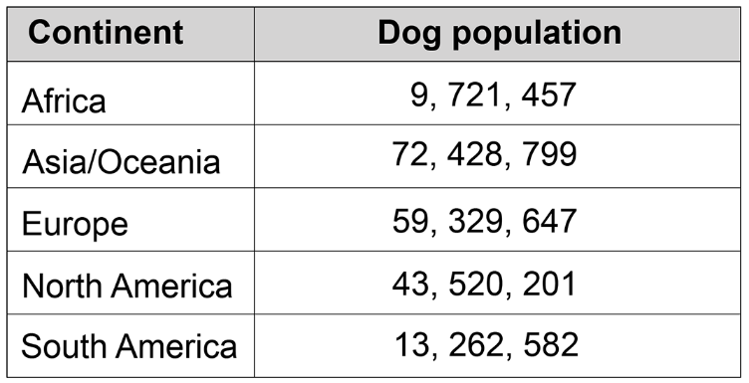
How many more dogs live in Europe than in Africa and South America combined?

End of Section Two

